**18. helm release workflow**

* In this lecture, I will walk you through the workflow or process. Helm goes through behind the scenes when we execute a helm installation.
* This is the same process, whether you are pulling a Helm Chart from a remote repository or using your own chart you have on your machine, which you will be learning in sections later. The process remains the same.

**What happened when we do helm install**

* The first thing Helm does when you do a Helm install is to load the chart and its dependencies.
* If it is a local chart, it will simply load it from your local machine. If it is a chart living on a repository, it will pull that chart and it will load it.
* Since we are using the MySQL chart, launch your web browser, search for mysql bitnami chart. I want to go to GitHub to see how the source of this chart will look like.

**Mysql bitnami chart in github explanation**

--- **mysql bitnami chart** – search using this word on google.

--- **Reference** - <https://github.com/bitnami/charts/tree/master/bitnami/mysql>

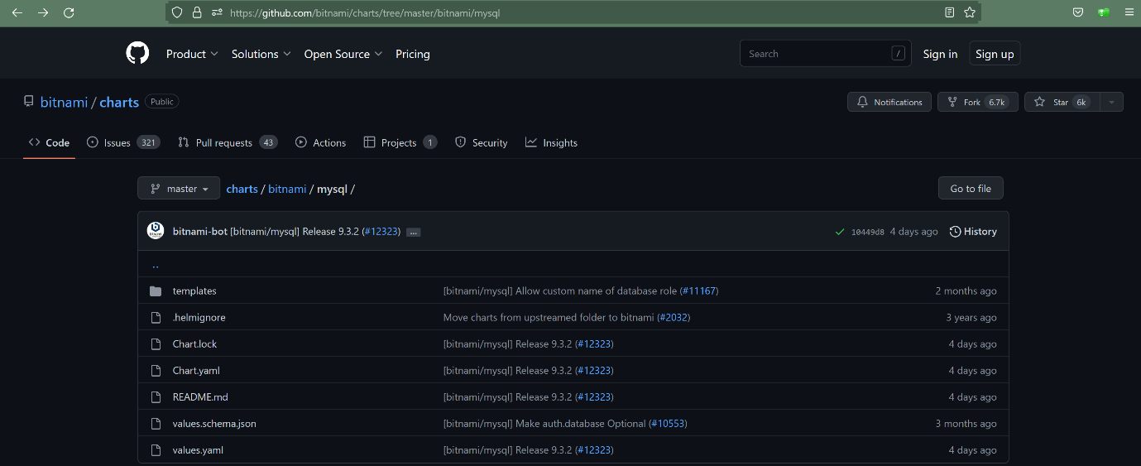

--- **values.yaml** – it has default values.yaml file, we can override the values.yml files with customized values.yml files. Which will given by us.

**Helm workflow**

Stage1 - it will load charts

Stage2 - substitute the values through values.yml

Stage3 - render the required kubernetes templates and formats those templates into yml

Stage4 – submit the yaml files to the kubernetes.